Contact Details
Scottish Swimming Tel 01786 466520
Email a.reed@scottishswimming.com

Azolve
Teacher/Coach Licence
Application Guidance
Application Guidance
SASA Education
2018
Contents
Logging into Membership System 1
Applying for your Teacher/Coach Licence 2
Adding your Qualificaitons via the Licensing Application 4
Completing your Licence Application 9

Logging into Membership System
Visit https://scottishswimming.azolve.com
Enter Username & Password – If you do not know this please E-Mail Alan Reed to request a password reset; you will receive an email with your details.

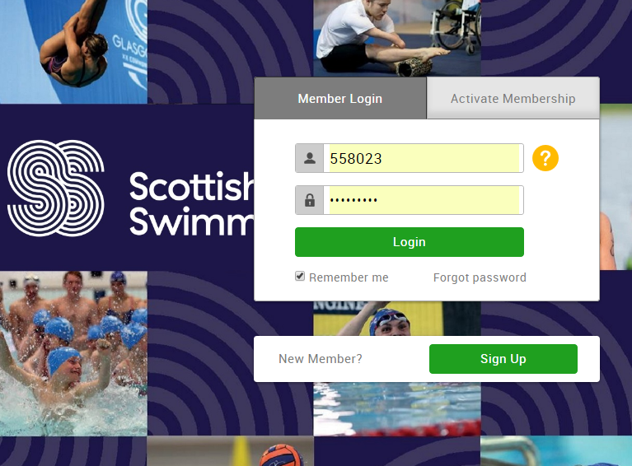

Applying for your Teacher/Coach Licence
Select the “Membership” tile.
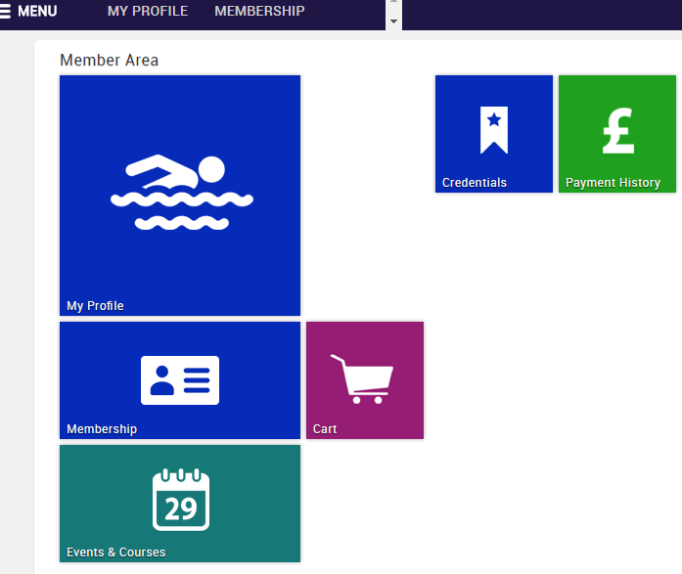

Select “Licensing” from the options.
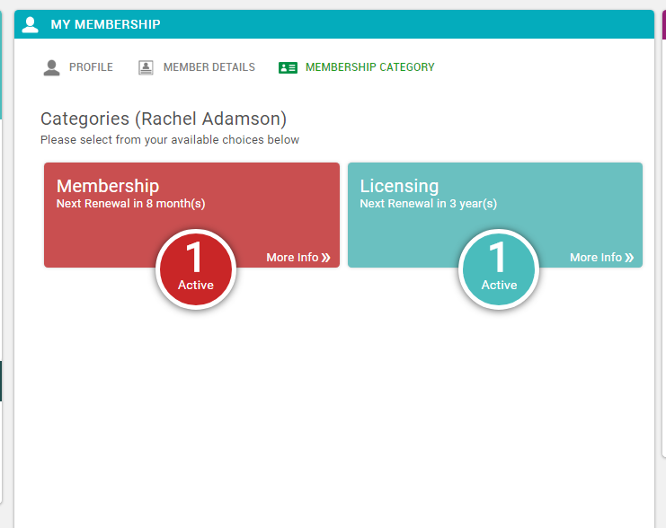

Select “Add”
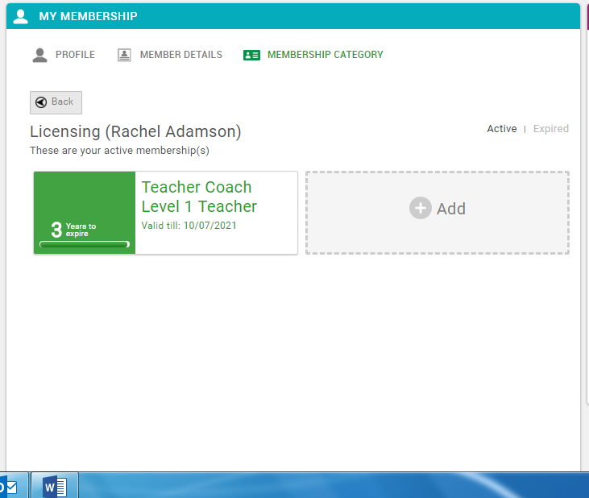

If you do not have this option to “add” this means you do not have the qualification and SPC linked to your membership. If you do hold these please continue to the Adding your Qualifications via the Licensing Application section.

Adding your Qualifications via the Licensing Application
If your membership record does not detail the relevant qualificaiton required for this licence but you do hold this, select “Add qualification”
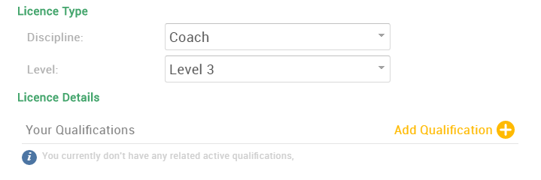

Search for Qualification Name 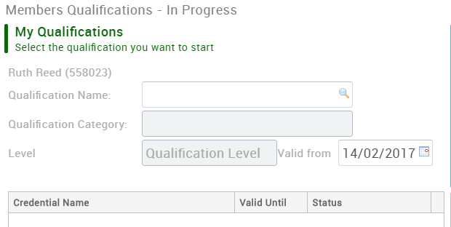

Select the relevant qualification you wish to add by selecting the
(Equivalent qualifications are designed for UKCC equivalents e.g. ASA qualifications)
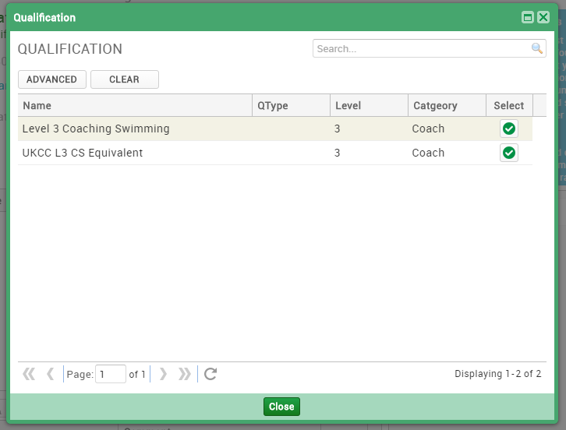

Select “Upload” & attach all relevant qualification certificates you have as evidence.
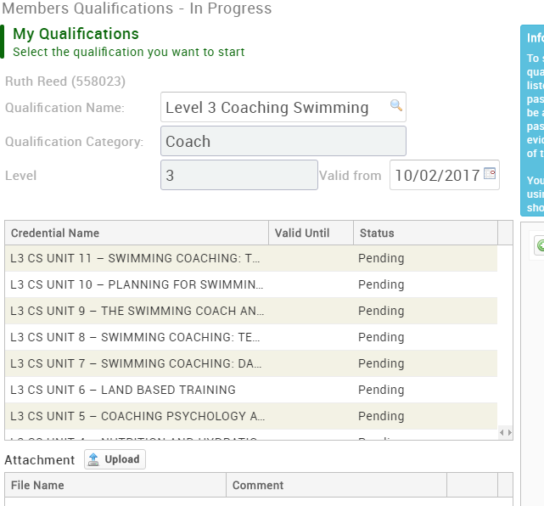

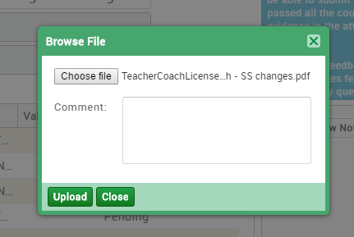
Enter file description here. E.g. UKCC L3 Coaching Swimming cert.

Select “Submit for Review”
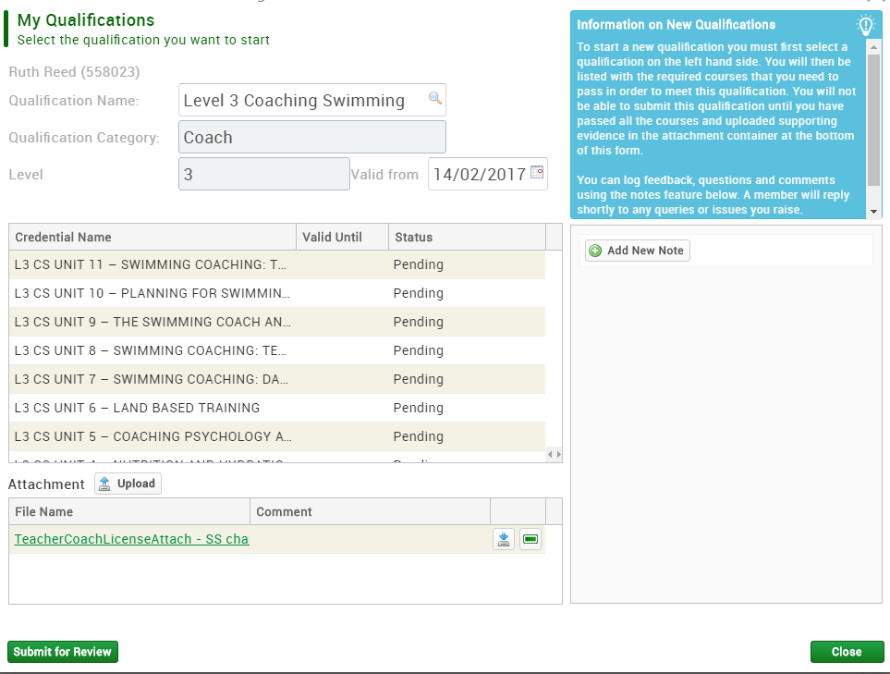
If you try to complete your licence application before your qualification is approved by Scottish Swimming, you will receive this pop up message.
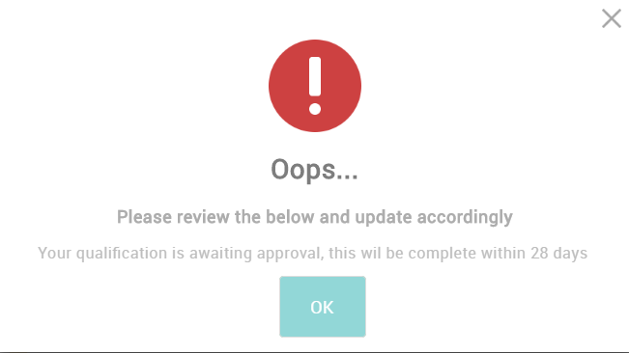

At this point, you should Log out and await your qualification confirmation email from Scottish Swimming, which will look something like this:
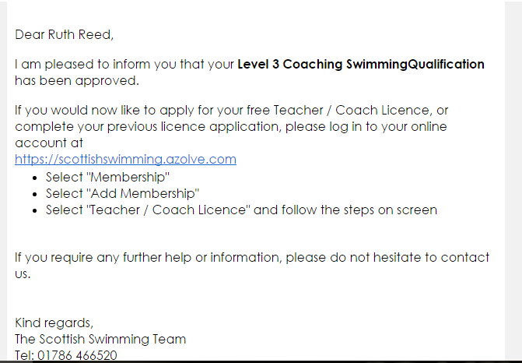

Completing your Licence Application
Once your Qualifications have been approved by Scottish Swimming you can continue with your licence application.
You will see that your qualification is now detailed under “Your Qualifications”
To confirm that you have a relevant PVG for the clubs /swimschool that you are working for tick the check box.
You must be a current and active teacher / coach with the club attached to your membership record.
Please read Code of Conduct & Code of Ethics to ensure that you agree and tick the check box to confirm.
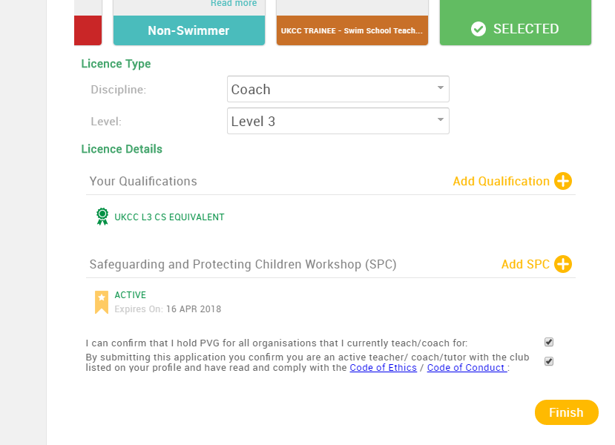
Once complete select “Finish”

You will be directed to your shopping cart.
Select “Complete Order” to complete the application
Or
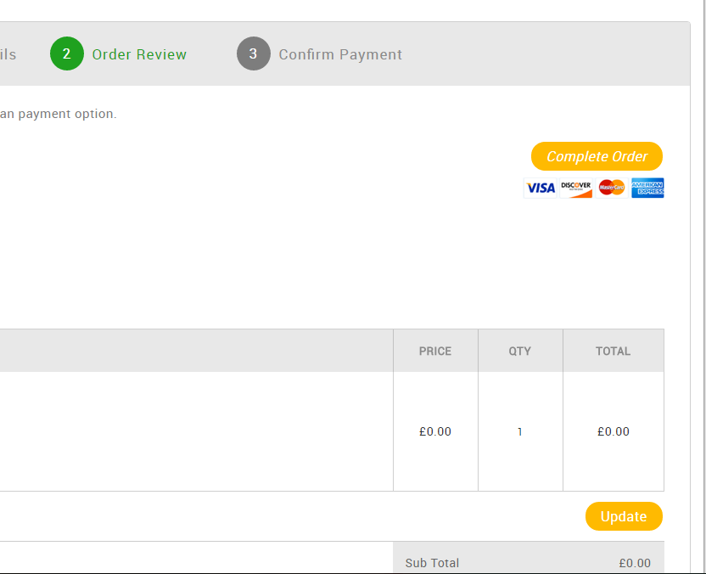
Return to menu and memberships to apply for further licences

Select “Home” to process the licence
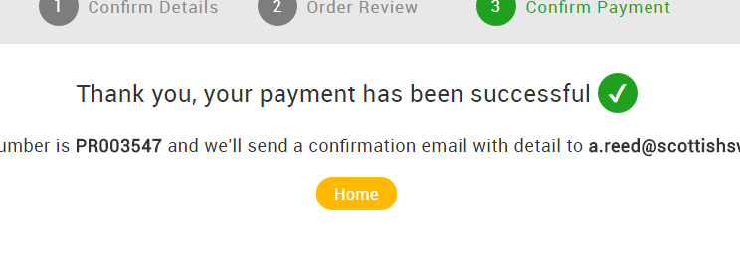

Once your licence has been approved you will then receive two emails:
- Confirmation of processing
- Licence approval with a PDF copy of the licence
Note: It may take a few minutes to arrive, please check Junk Email
Your Licence approval email will look like this:
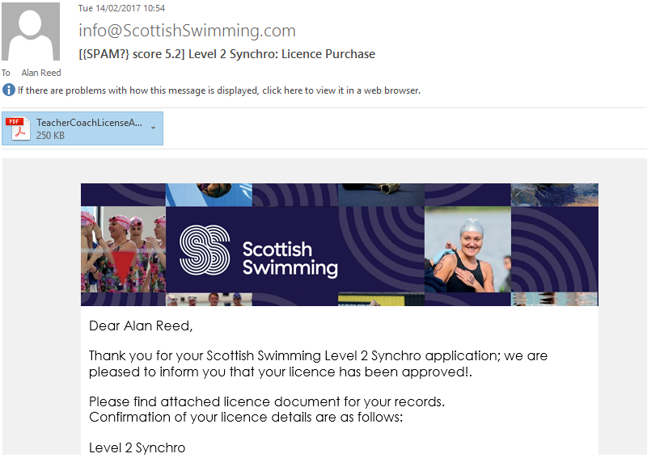

Your PDF Licence will look like this:
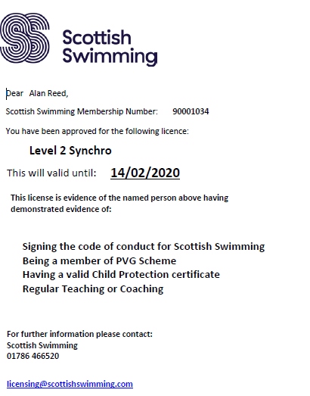

Your Licence is now complete!

