Contact Details

Scottish Swimming Tel 01786 466520

Email a.reed@scottishswimming.com



**Azolve**

**Teacher/Coach Licence**

**Application Guidance**

Application Guidance

SASA Education

2018

Contents

Logging into Membership System 1

Applying for your Teacher/Coach Licence 2

Adding your Qualificaitons via the Licensing Application 4

Completing your Licence Application 9

# Logging into Membership System

Visit <https://scottishswimming.azolve.com>

Enter Username & Password – If you do not know this please [E-Mail](mailto:a.reed@scottishswimming.com?subject=Password%20Reset%20Scottish%20Swimming%20membership) Alan Reed to request a password reset; you will receive an email with your details.

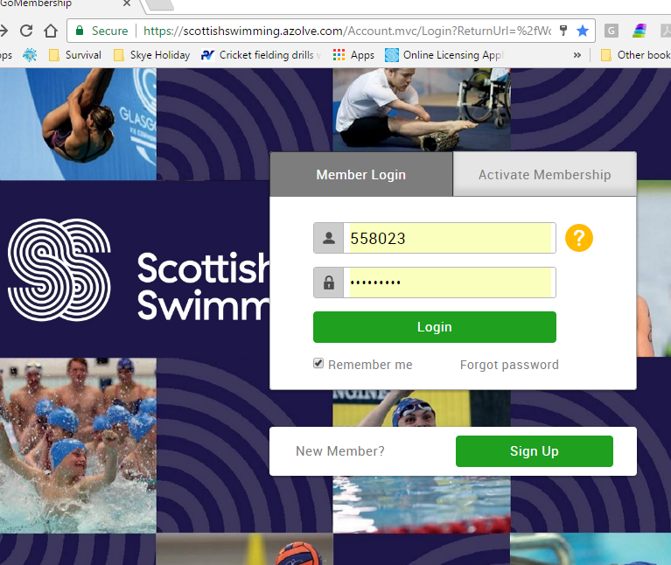

# Applying for your Teacher/Coach Licence

**Select the “Membership” tile.**

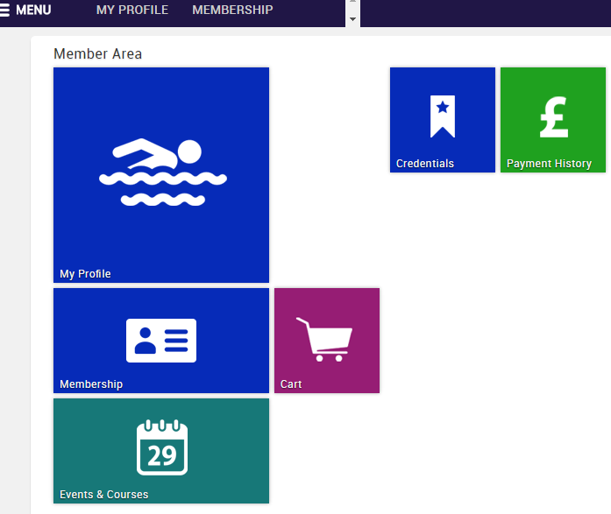

**Select “Licensing” from the options.**

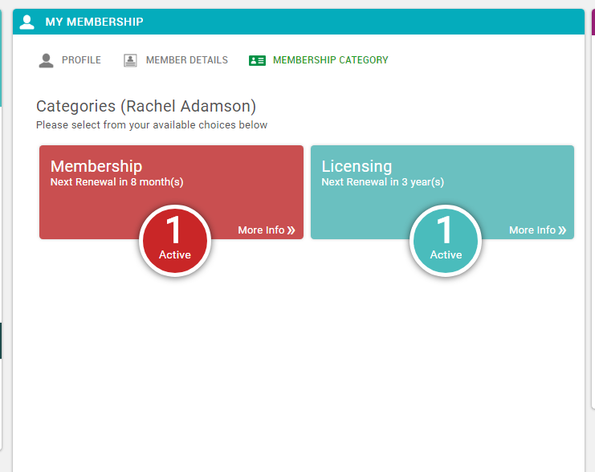

**Select “Add”**

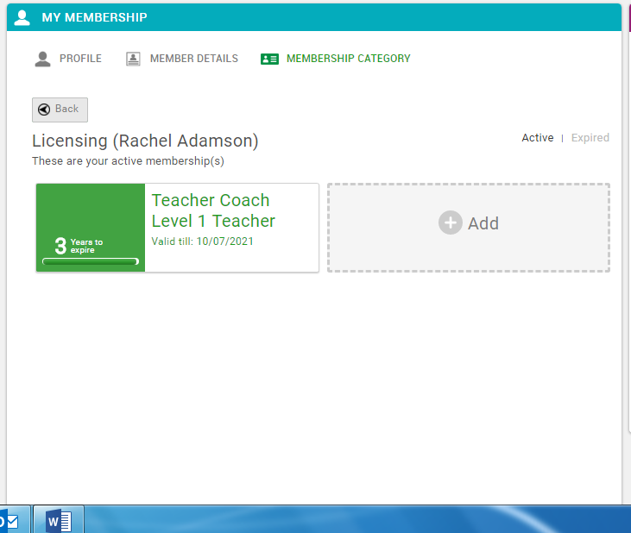

If you do not have this option to “add” this means you do not have the qualification and SPC linked to your membership. If you do hold these please continue to the Adding your Qualifications via the Licensing Application section.

# Adding your Qualifications via the Licensing Application

If your membership record does not detail the relevant qualificaiton required for this licencebut you do hold this**, select “Add qualification”**

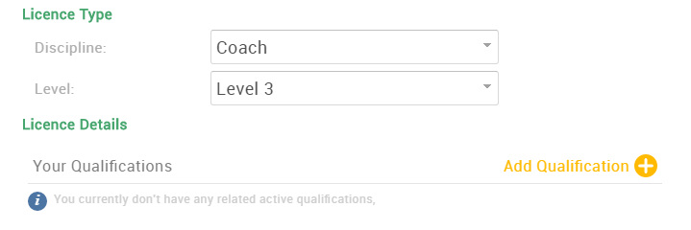

**Search for Qualification Name** 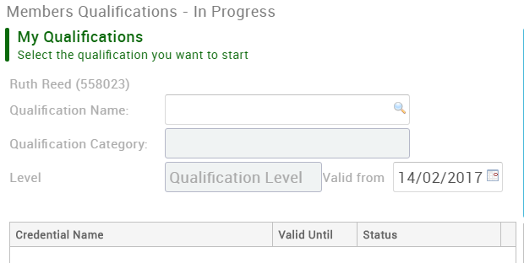

**Select the relevant qualification you wish to add by selecting the** 

(Equivalent qualifications are designed for UKCC equivalents e.g. ASA qualifications)

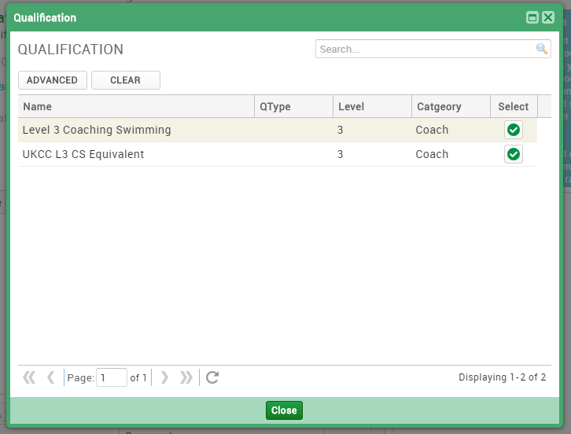

**Select “Upload” & attach all relevant qualification certificates you have as evidence.**

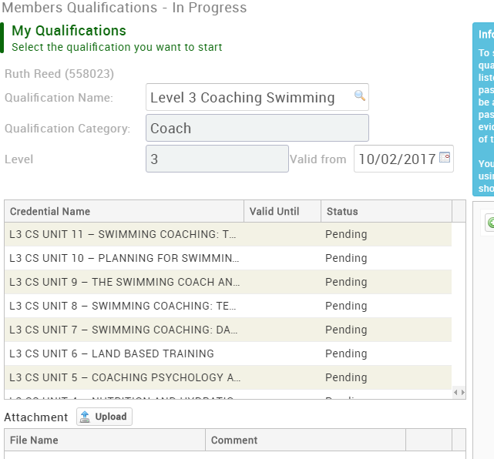

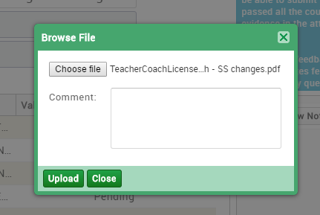

Enter file description here. E.g. UKCC L3 Coaching Swimming cert.

**Select “Submit for Review”**

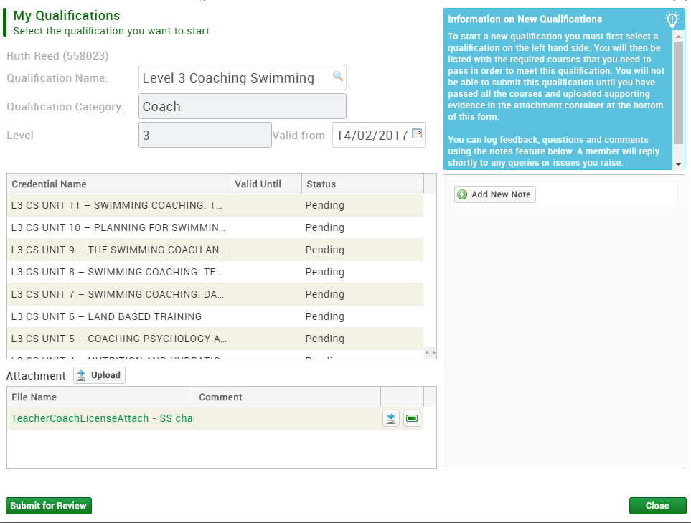

If you try to complete your licence application before your qualification is approved by Scottish Swimming, you will receive this pop up message.

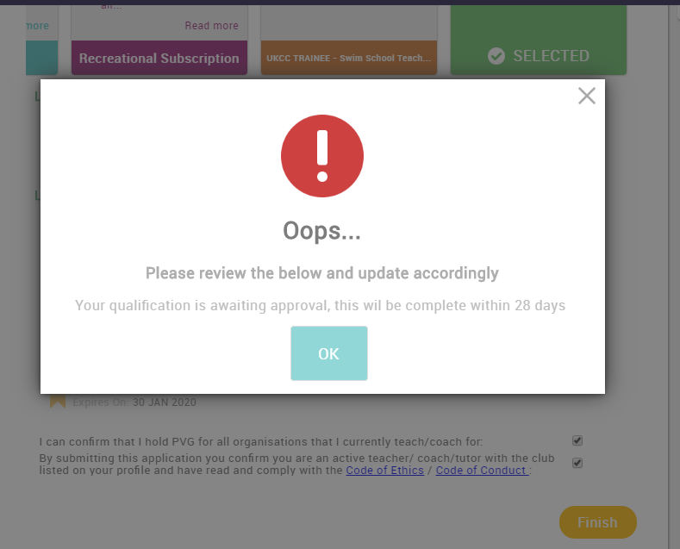

At this point, you should Log out and await your qualification confirmation email from Scottish Swimming, which will look something like this:

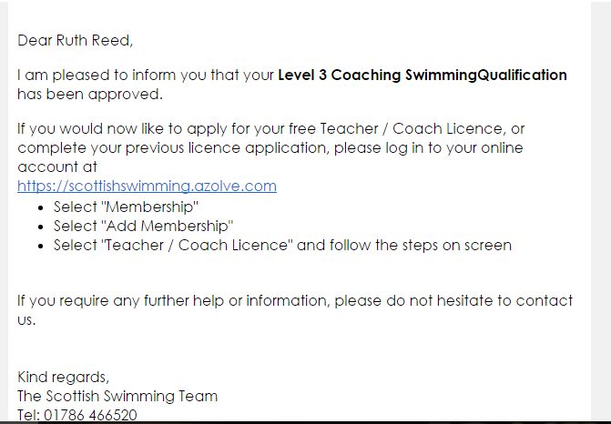

# Completing your Licence Application

Once your Qualifications have been approved by Scottish Swimming you can continue with your licence application.

You will see that your qualification is now detailed under “Your Qualifications”

To confirm that you have a relevant PVG for the clubs /swimschool that you are working for **tick the check box.**

You must be a current and active teacher / coach with the club attached to your membership record.

Please **read Code of Conduct & Code of Ethics** to ensure that you agree and **tick the check box** to confirm.

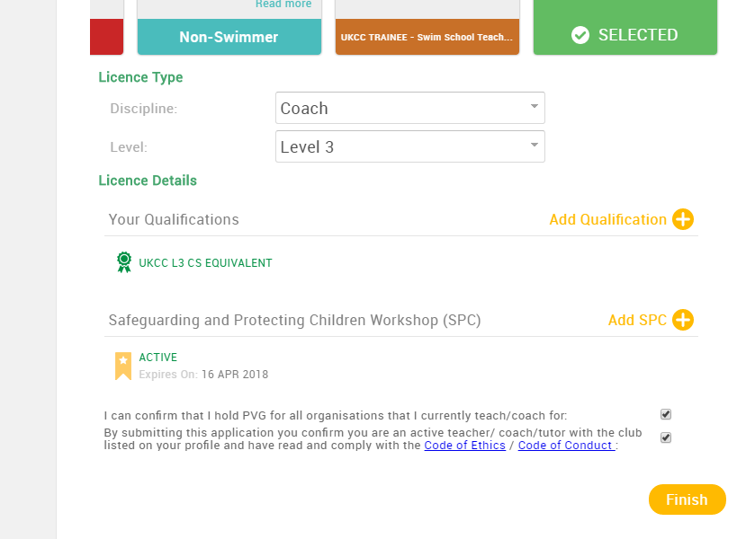Once complete select **“Finish”**

You will be directed to your shopping cart.

**Select “Complete Order” to complete the application**

Or

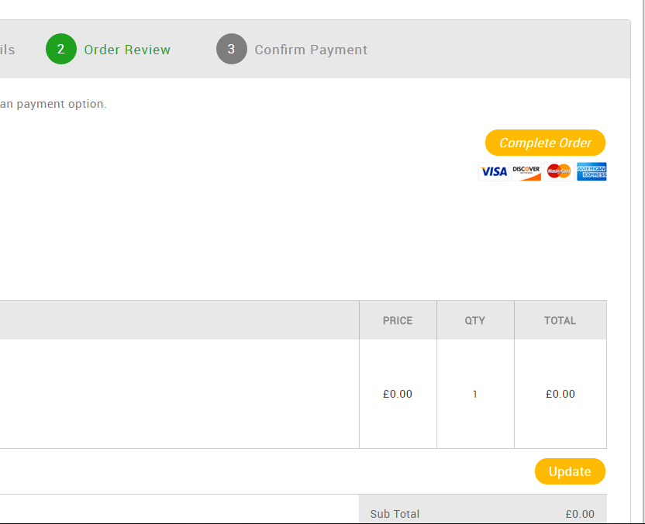Return to menu and memberships to apply for further licences

**Select “Home” to process the licence**

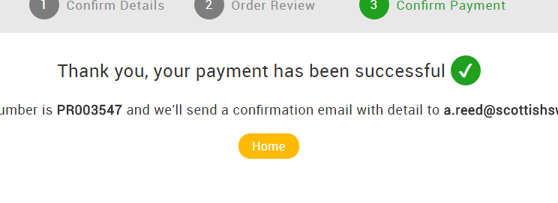

**Once your licence has been approved you will then receive two emails:**

* Confirmation of processing
* Licence approval with a PDF copy of the licence

**Note: It may take a few minutes to arrive, please check Junk Email**

Your Licence approval email will look like this:

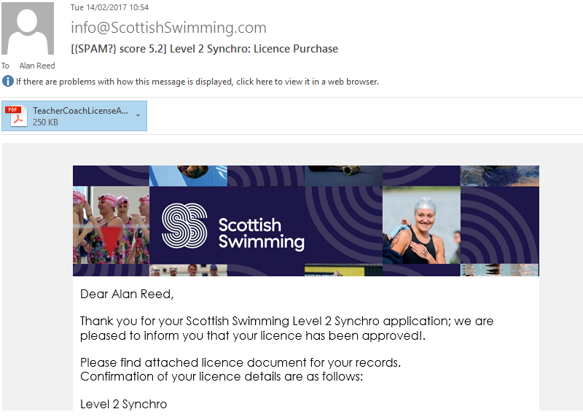

Your PDF Licence will look like this:

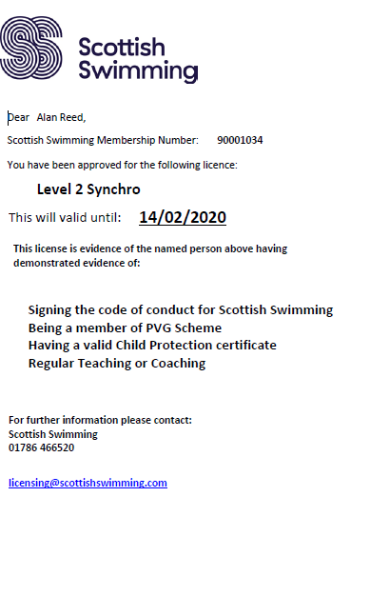

**Your Licence is now complete!**